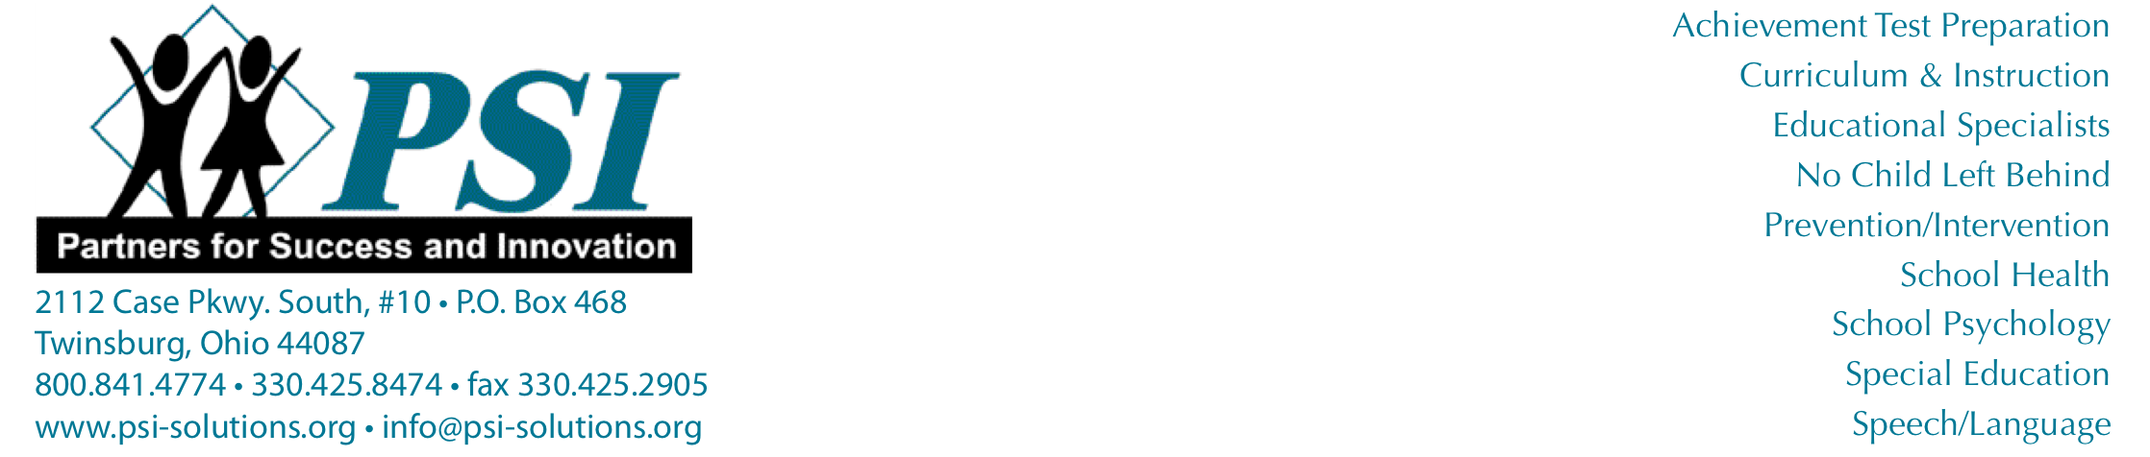

Permission to Screen for Speech and Language

Dear Parent:

We are interested in your child’s communication success at school; therefore, your child’s teacher referred ________________________________________________ to the school’s speech-language pathologist for an individual screening. To gain more information about your child’s communication skills, this screening may include articulation, voice, fluency, and language measures.

In order for this to be accomplished, your consent must be obtained. All information gathered will be shared with you at your request.

**Please check the appropriate box and return this letter to your child’s teacher.**

If you have any questions, please feel free to contact me at _____________________________.

Thank you,

______________________________________________ Date: _________________________________

Speech-Language Pathologist

Yes, I give my consent for my child to be screened.

No, I do not give my consent for communication screening.

Comments: _________________________________________________________________________________________________

Signature: ___________________________________________ Date: _________________________________

Note: When routine screenings are done for an entire grade level or class, permission is not required.