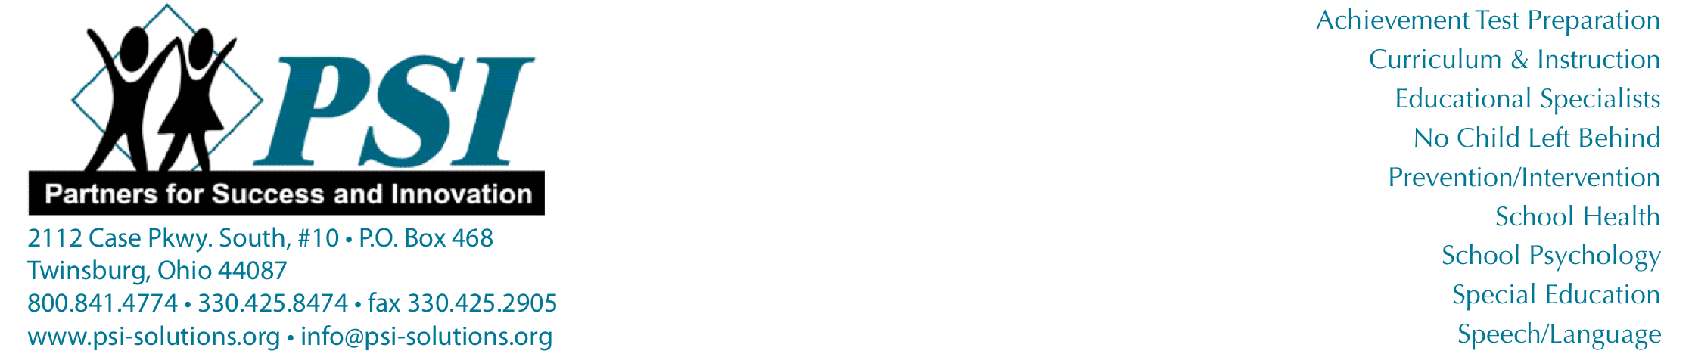

Speech-Language Screening Report

Student: | Date:
SLP: | School:

Results/Recommendations of Speech-Language Screening:

Student’s speech-language skills are presently within normal limits and further speech-language testing is not recommended at this time.

Student’s speech-language skills need to be monitored in one or more of the following areas to determine if further testing will be suggested at a later time:
Articulation
Errors noted:_____________________________________________________________________________

Receptive/Expressive Language Skills
Weakness(es) noted: ____________________________________________________________________

Voice

Fluency

Pragmatic Language Skills

The Speech-Language Pathologist will be contacting you to discuss the results of the screening.

