Daisy, Daisy

(On a bicycle built for two)

Daisy, Daisy
Give me your answer do
I'm half crazy all for the love of you
It won't be a stylish marriage
I can't afford a carriage
But you look sweet
Upon a seat
Of a bicycle built for two

Shine on Harvest Moon

Oh, Shine on, shine on, harvest moon
Up in the sky;
I ain't had no lovin'
Since January, February, June or July.
Snow time ain't no time to stay
Outdoors and spoon;
Shine on, shine on, harvest moon,
For me and my gal.

For It Was Mary

For it was Mary, Mary, plain as any name can be;
But with propriety, society will say 'Marie'.
But it was Mary, Mary, long before the fashions came:
And there is something there that sounds so fair,
It's a grand old name!

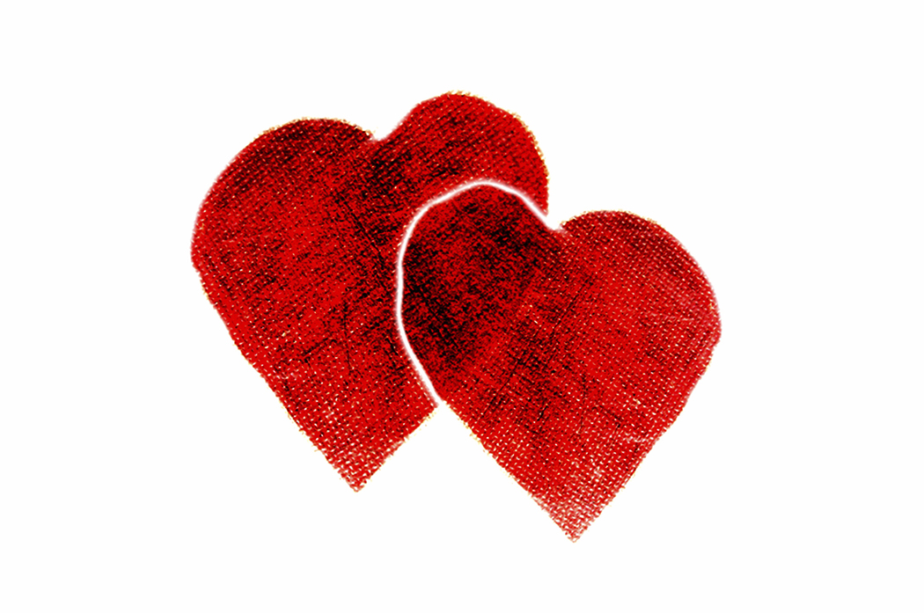
You Made Me Love You

You made me me love you,
I didn't wanna to do it, I didn't wanna do it,
You made me want you, and all the time you knew it,
I guess you always knew it,
You made me happy, sometimes you made me glad,
But there were times, dear, you made me feel so bad . . .
You made me sigh for,
I didn't wanna tell you, didn't wanna tell you,
I want some love that's true, yes I do,
'Deed I do, you know I do,
Gimmy, gimmy me what I cry for,
You know you got the brand of kisses that I die for,
You know you made me love you !

The Girl That I Marry
The girl that I marry will have to be
As soft and as pink as a nursery
The girl I call my own
Will wear satin and laces and smell of cologne
Her nails will be polished
And in her hair she'll wear a gardenia
And I'll be there
Instead of flittin', I'll be sittin'
Next to her, and she'll purr like a kitten
A doll I can carry,
The girl that I marry must be.


I Can’t Give You Anything But Love
I can't give you anything but love, Baby,
That's the only thing I've plenty of, Baby.
Dream awhile, scheme awhile, We're sure to find,
Happiness, and I guess, All those things you've always pined for.
Gee, I'd like to see you looking swell, Baby,
Diamond bracelets Woolworth doesn't sell, Baby.
Till that lucky day, you know darned well, Baby,
I can't give you anything but love.


I Don’t Know Why
I don't know why I love you like I do
I don't know why I just do
I don't know why you thrill me like you do
I don't know why you just do
You never seem to want my romancing
The only time you hold me
Is when we're dancing
I don't know why I love you like I do
I don't know why I just do


If You Were the Only Girl in the World
If you were the only girl in the world
and I were the only boy
nothing else would matter in the world today
we could go on loving in the same old way.
A garden of Eden just made for two
with nothing to marr our joy
then I would say such wonderful things to you
there would be such wonderful things to do
if you were the only girl in the world
and I were the only boy.
Oh, You Beautiful Doll
Oh, you beautiful doll,
you great big beautiful doll.
Let me put my arms about you,
I don't want to live without you.
Oh, you beautiful doll,
you great big beautiful doll.
If you ever leave me,
how my heart would ache.
I want to hug you, but
I fear you'd break.
Oh, oh, oh, oh.
Oh, you beautiful doll.

By the Light of the Silvery Moon

By the light (not the dark but the light)
Of the silvery moon (not the sun but the moon)
I want to spoon (not croon, but spoon)
To my honey I'll croon love's tune
Honey moon, honey moon, honey moon
Keep a-shining in June
Your silvery beams will bring love's dreams
We'll be cuddling soon
By the silvery moon
The silvery moon...
Side by Side
Oh we ain't got a barrel of money
maybe we're ragged and funny
But we'll travel along
singing a song, side by side
Well don't know what's coming
tomorrow
maybe it's trouble and sorrow
But we'll travel the road
sharing our load
side by side
Oh honey through all kind of weather
what if the sky should fall
Just as long as we're together
it doesn't matter at all
When they've all had their quarrels
and parted
we'll be the same as we
started
Just traveling along
singing a song
side by side

Tie a Yellow Ribbon Round the Old Oak Tree
I’m comin’ home, I’ve done my time
Now I’ve got to know what is and isn’t mine
If you received my letter telling you I’d soon be free
Then you’ll know just what to do
If you still want me.

Oh tie a yellow ribbon
'Round the old oak tree
It's been three long years
Do you still want me?
If I don't see a ribbon
'Round the old oak tree
I'll stay on the bus, forget about us
And put the blame on me
If I don't see a yellow ribbon
'Round the old oak tree.
Let Me Call You “Sweetheart”

Let me call you "Sweetheart," I'm in love with you.
Let me hear you whisper that you love me too.
Keep the love-light glowing in your eyes so true.
Let me call you "Sweetheart," I'm in love with you.

Down by the Old Mill Stream

Down by the old (not the new but the old)
Mill stream (not the river but the stream),
Where I first (not the last but the first)
Met you. (Not me but you.)
With your eyes (not your ears, but your eyes)
Of blue (not green, but blue).
Dressed in ging- (not silk but ging-) -ham too. (Not one but two.)
And it was there (not here, but there),
I knew (not old, but new)
That you loved (not hate, but loved)
Me too. (Not one but two.)
You were sixteen (not seventeen, but sixteen)
My village queen! (Not the king, but the queen).
Down by the old (not the new, but the old),
Mill stream (not the river, but the stream).

Red River Valley
From this valley they say you are going
We will miss your bright eyes and sweet smile
For they say you are taking the sunshine
That has brightened our path for a while
Come and sit by my side if you love me
Do not hasten to bid me adieu
But remember the Red River Valley
And the cowboy who loved you so true
Won't you think of the valley you're leaving
Oh how lonely, how sad it will be?
Oh think of the fond heart you're breaking
And the grief you are causing to me
As you go to your home by the ocean
May you never forget those sweet hours
That we spent in the Red River Valley
And the love we exchanged mid the flowers

Have I Told You Lately That I Love You?

Have I told you lately that I love you
Could I tell you once again somehow
Have I told with all my heart and soul how I adore you
Well darlin' I'm telling you now
My world would end today if I should lose you
I'm no good without you, anyhow
This heart would break in two if you refuse me
Well darlin' I'm telling you now
Have I told you lately how I miss you
When the stars are shining in the sky
Have I told you why the nights are long
When you're not with me
Well darlin' I'm telling you now
My world would end today if I should lose you
I'm just no good without you, anyhow
This heart would break in two if you refuse me
My darlin', I'm telling you now...

Darling Clementine
In a cavern, in a canyon,
Excavating for a mine
Dwelt a miner forty niner,
And his darling Clementine.
Chorus:
Oh my darling, oh my darling, oh my darling, Clementine!
Thou art lost and gone forever, dreadful sorry, Clementine
Light she was and like a fairy,
And her shoes were number nine,
Herring boxes, without topses,
Sandals were for Clementine.
(Chorus)
Drove she ducklings to the water
Ev'ry morning just at nine,
Hit her foot against a splinter,
Fell into the foaming brine.
(Chorus)
Ruby lips above the water,
Blowing bubbles, soft and fine,
But, alas, I was no swimmer
So I lost my Clementine.
(Chorus)
How I missed her! How I missed her,
How I missed my Clementine,
But I kissed her little sister,
I forgot my Clementine.
(Chorus)
K-K-K-Katy

Jimmy was a soldier brave and bold,
Katy was a maid with hair of gold,
Like an act of fate, Kate was standing at the gate,
Watching all the boys on dress parade.
Jimmy with the girls was just a gawk,
Stuttered ev'ry time he tried to talk,
Still that night at eight, He was there at Katy's gate,
Stuttering to her this love sick cry.
K-K-K-Katy, beautiful Katy,
You're the only g-g-g-girl that I adore;
When the m-m-m-moon shines, Over the cowshed,
I'll be waiting at the k-k-k-kitchen door.
K-K-K-Katy, beautiful Katy,
You're the only g-g-g-girl that I adore;
When the m-m-m-moon shines, Over the cowshed,
I'll be waiting at the k-k-k-kitchen door.
No one ever looked so nice and neat,
No one could be just as cute and sweet,
That's what Jimmy thought,
When the wedding ring he bought,
Now he's off to France the foe to meet.
Jimmy thought he'd like to take a chance,
See if he could make the Kaiser dance,
Stepping to a tune,
All about the silv'ry moon,
This is what they hear in far off France.
K-K-K-Katy, beautiful Katy,
You're the only g-g-g-girl that I adore;
When the m-m-m-moon shines, Over the cowshed,
I'll be waiting at the k-k-k-kitchen door.
Dream a Little Dream of Me

Stars shining bright above you;
Night breezes seem to whisper I love you.
Birds singing in the sycamore tree.
Dream a little dream of me.
Say nighty-night and kiss me;
Just hold me tight and tell me you'll miss me.
While I'm alone, blue as can be,
Dream a little dream of me.
Stars fading but I linger on, dear---
Still craving your kiss.
I'm longing to linger till dawn, dear,
Just saying this...
Sweet dreams till sunbeams find you---
Sweet dreams that leave all worries behind you.
But in your dreams, whatever they be,
Dream a little dream of me.

For Me and My Gal
The bells are ringing for me and my gal
Oh the birds are singing for me and my gal
Well everyone's been knowing to a wedding they’re going
And for weeks they've been sewing every Susie and Sal
They're congregating for me and my gal
While the parson's waiting for me and my gal
And sometime I'm going to build a little home for two three or four or more
In love land for me and my gal
And sometime I'm going to build a little home for two three or four or more
In love land for me and my gal.

Dr. Tim Rasinski
Kent State University
Kent, Ohio
trasinsk@kent.edu
330-672-0649

Old Familiar Love Songs
for
Valentine’s Day

