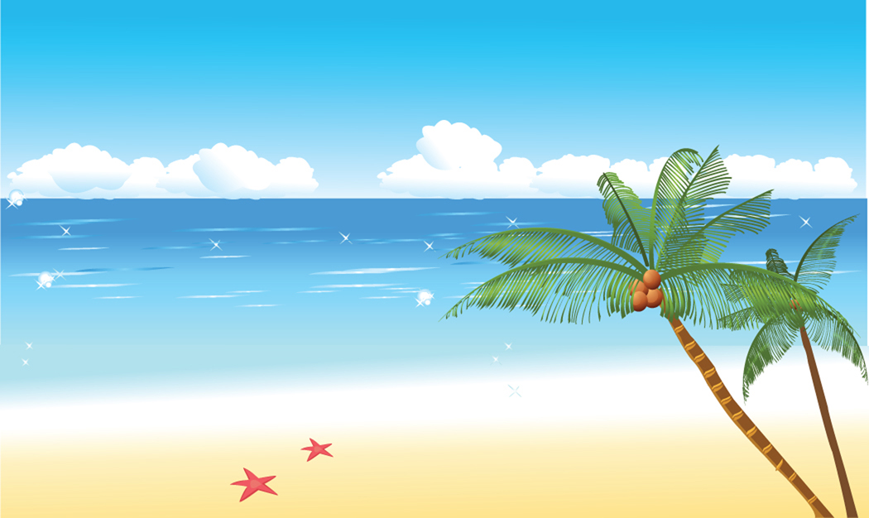
Those Lazy Hazy Crazy Days of Summer

Roll out those lazy, hazy, crazy days of summer
Those days of soda and pretzels and beer
Roll out those lazy, hazy, crazy days of summer
Dust off the sun and moon and sing a song of cheer

Just fill your basket full of sandwiches and weenies
Then lock the house up, now you're set
And on the beach you'll see the girls in their bikinis
As cute as ever but they never get 'em wet

Roll out those lazy, hazy, crazy days of summer
Those days of soda and pretzels and beer
Roll out those lazy, hazy, crazy days of summer
You'll wish that summer could always be here

See You in September

I'll be alone each and every night
While you're away, don't forget to write
See you in September
See you when the summer's through
Here we are
Saying goodbye at the station
Summer vacation
Is taking you away
Have a good time but remember
There is danger in the summer moon above
Will I see you in September
Or lose you to a summer love?

By the Beautiful Sea

By the sea, by the sea, by the beautiful sea!

You and me, you and me, oh how happy we'll be!

When each wave comes a-rolling in

We will duck or swim,

And we'll float and fool around the water.

Over and under, and then up for air,

Pa is rich, Ma is rich, so now what do we care?

I love to be beside your side, beside the sea,

Beside the seaside, by the beautiful sea!

Summer Wind


The summer wind came blowin' in

From across the sea

It lingered there so warm and fair

All summer long

we sang a song

And then we strolled on golden sand

Two friends

and the summer wind

Like painted skies, those days and nights

They went flying by

The world was new

Beneath the bright blue

Umbrella sky

Then softer than

That piper man

One day, it called to you

And I lost you

I lost you to

The summer wind

The Things We Did Last Summer

The boat rides we would take, the moonlight on the lake

The way we danced and hummed our fav'rite song

The things we did last summer I'll remember all winter long

The midway and the fun, the kewpie dolls we won

The bell I rang to prove that I was strong

The things we did last summer I'll remember all winter long

The early morning hike, the rented tandem bike

The lunches that we used to pack

We never could explain that sudden summer rain

The looks we got when we got back

The leaves began to fade like promises we made

How could a love that seemed so right go wrong?

The things we did last summer I'll remember all winter long

Love Letters in the Sand

On a day like today,

We pass the time away

Writing love letters in the sand.

Oh, you laughed when I cried

Each time I saw the tide

Take our love letters in the sand.

You made a vow that you would always be true

But somehow, that vow meant nothing to you

Now my poor heart just aches

With every wave that breaks

Over love letters in the sand.

Summertime

Summertime and the livin' is easy

Fish are jumpin' and the cotton is fine

Oh your Daddy's rich and your ma is good lookin'

So hush little baby, don't you cry

One of these mornings

You're goin' to rise up singing

Then you'll spread your wings

And you'll take the sky

But till that morning

There's a nothin' can harm you

With daddy and mammy standin' by

Take Me Out to the Ballgame
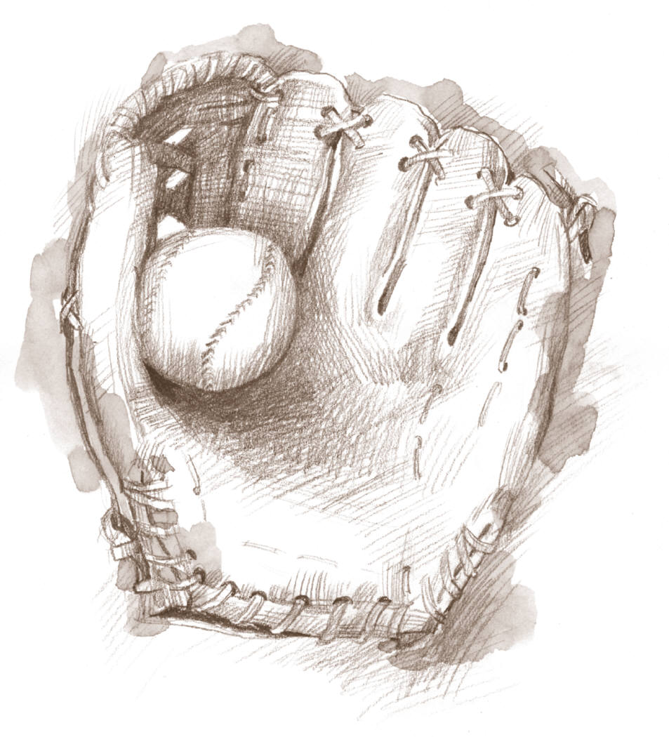
Take me out to the ball game,
Take me out with the crowd.
Buy me some peanuts and cracker jack,
I don't care if I never get back,
Let me root, root, root for the home team,
If they don't win it's a shame.
For it's one, two, three strikes, you're out,
At the old ball game.

You Are My Sunshine

You are my sunshine, my only sunshine

You make me happy when skies are grey

You'll never know dear, how much I love you

Please don't take my sunshine away

The other night dear, as I lay sleeping

I dreamed I held you in my arms

So I hung my head and I cried.

When I awoke, dear, I was mistaken

You are my sunshine, my only sunshine

You make me happy when skies are grey

You'll never know dear, how much I love you

Please don't take my sunshine away

In The Good Old Summertime

In the good old summertime

In the good old summertime

Strolling thru' a shady lane

With your baby mine

You hold her hand and she holds yours

And that's a very good sign

That she's your tootsey-wootsey

In the good, old summertime

Little White Duck

There's a little white duck sitting in the water

Little white duck doing what he oughta

He took a bite of a lily pad

Flapped his wings and he said "I'm glad"

That I'm a little white duck sitting in the water

Quack, quack, quack

There's a little green frog swimming in the water

Little green frog doing what he oughta

He jumped right off of the lily pad

That the little duck bit and he said "I'm glad"

That I'm a little green frog swimming in the water

Gulp, gulp, gulp

There's a little black bug floating on the water

A little black bug doing what he oughta

He tickled the frog on the lily pad

That the little duck bit and he said "I'm glad"

That I'm a little black bug floating on the water

Quick, quick, quick

There's a little red snake lying in the water

A little red snake doing what he oughta

He frightened the duck and the frog so bad

And he ate the little bug and he said "I'm glad"

That I'm a little red snake lying in the water

Sss, sss, sss

And now there's nobody left left sitting in the water

Nobody left doing what he oughta

Nothing left but the lily pad

The duck and the frog ran away

There's nobody left sitting in the water

Boo, hoo, hoo

Summer in the City

Hot town, summer in the city

Back of my neck getting dirty and gritty

Been down, Isn't it a pity

Doesn't seem to be a shadow in the city

All around, people looking half dead

Walking on the sidewalk, hotter than a match head.

But at night it's a different world

Go out and find a girl

Come-on come-on and dance all night

Despite the heat it'll be alright

And babe, don't you know it's a pity

That the days can't be like the nights

In the summer, In the city, In the summer,

In the city

Cool town, evening in the city

Dressing so sharp and looking so pretty

Cool cat, looking for a kitty

Gonna look in every corner of the city

Till I'm wheezing at a bus stop

Running up the stairs, gonna meet you at the rooftop.

But at night it's a different world

Go out and find a girl

Come-on come-on and dance all night

Despite the heat it'll be alright

And Babe, don't you know it's a pity

That the days can't be like the nights

In the summer, In the city, In the summer,

In the city

Kokomo

Aruba, Jamaica, ooh I want to take ya

Bermuda, Bahama, come on, pretty mama

Key Largo, Montego, baby, why don't we go Jamaica

Off the Florida Keys

There's a place called Kokomo

That's where you want to go

To get away from it all

Bodies in the sand

Tropical drink melting in your hand

We'll be falling in love

To the rhythm of a steel drum band

Down in Kokomo

{Refrain}

Aruba, Jamaica, ooh I want to take ya

To Bermuda, Bahama, come on, pretty mama

Key Largo, Montego, baby, why don't we go

Ooh I want to take you

Down to Kokomo

We'll get there fast and then we'll take it slow

That's where we want to go

Way down in Kokomo

Itsy Bitsy Teenie Weenie Yellow Polka Dot Bikini

She was afraid to come out of the locker
She was as nervous as she could be
She was afraid to come out of the locker
She was afraid that somebody would see
---Two three four tell the people what she wore
It was an Itsy Bitsy Teenie Weenie Yellow Polka Dot Bikini
That she wore for the first time today
An Itsy Bitsy Teenie Weenie Yellow Polka Dot Bikini
So in the locker, she wanted to stay
----Two three four stick around we'll tell you more
She was afraid to come out in the open
So a blanket around her she wore
She was afraid to come out in the open
So she sat, bundled up on the shore
----Two three four tell the people what she wore
It was an Itsy Bitsy Teenie Weenie Yellow Polka Dot Bikini
That she wore for the first time today
An Itsy Bitsy Teenie Weenie Yellow Polka Dot Bikini
So in the blanket, she wanted to stay
----Two three four the stick around we'll tell you more
Now she's afraid to come out of the water
And I wonder what she's gonna do
Now she's afraid to come out of the water
And the poor little girl's turning blue
----Two thee four tell the people what she wore
It was an Itsy Bitsy Teenie Weenie Yellow Polka Dot Bikini
That she wore for the first time today
An Itsy Bitsy Teenie Weenie Yellow Polka Dot Bikini
So in the water, she wanted to stay.

